

PRESS RELEASE Prague, 1st June 2018

PASSERINVEST GROUP is the sixth most admired firm in the Czech Republic for the year 2018

PASSERINVEST GROUP, the leading Czech development and investment company, ranked sixth among the ALL STARS of the most admired companies in the Czech Republic in the year 2018. The company simultaneously ranked first in the category of Activities in the area of real estate, enterprise services. Each year the CZECH TOP 100 association organises and announces the list of the 100 most admired companies of the Czech Republic.

PASSERINVEST GROUP, a Czech development and investment company known in the capital city mainly thanks to the construction of the multifunctional BB Centrum complex and in the Moravian-Silesian Region due to the Nová Karolina Park project, improved by two places in the main category, compared to last year’s eighth place, and it defended its victory in its field of operations. Thus it confirmed its exceptional position in the competition of all the companies operating in the Czech Republic.

The awards ceremony of the “100 most admired companies in the Czech Republic for the year 2018”, which was organised by CZECH TOP 100, was held in April 2018 in the French Restaurant of the Municipal House. The order of the rankings of the CZECH TOP 100 is compiled on the basis of the evaluation of managers of important companies, economic and financial analysts and representatives of trade associations, unions and professional associations.

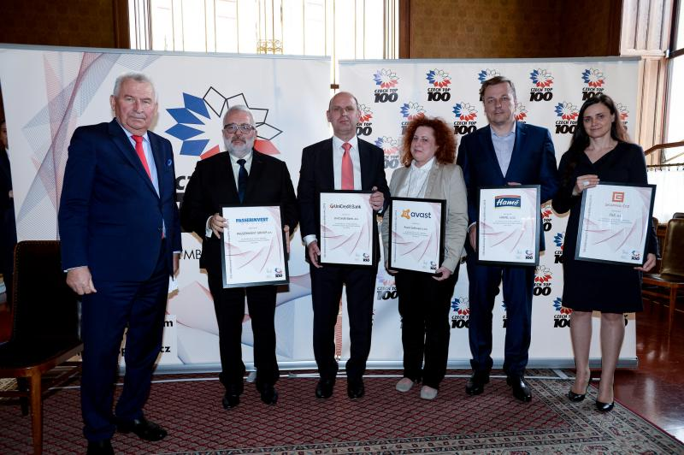

Second from the left: Vladimír Klouda, the Executive Director of PASSERINVEST GROUP, accepts the award

For more information and photographs in print quality please contact:

Kristýna Samková, Head of PR and Marketing dept.
PASSERINVEST GROUP, a.s.
Tel.: (+420) 221 582 111
Mobil: (+420) 602 186 708
E-mail: Kristyna.Samkova@Passerinvest.cz
www.passerinvest.cz, www.bbcentrum.cz

Marcela Štefcová
Crest Communications a.s.
Mobil: (+420) 731 613 669
E-mail: marcela.stefcova@crestcom.cz

About the Developer

PASSERINVEST GROUP, a.s., founded in 1991 by Radim Passer, is a purely Czech development and investment company whose name is associated in particular with the BB Centrum multifunctional complex in Prague 4 - Michle. With this project, the most successful and extensive Czech project of its type, the company has built its excellent reputation both at home and at the international level. Contributing to this is not only the high quality of the projects completed to date, but also its high level of service, its sense of fair play, its positive relationship with the tenants and users of its buildings, and its sense of responsibility towards society and the environment. PASSERINVEST GROUP’sportfolio includes other interesting development projects.

